# Project 1

# Correlation between College Enrollment, Graduation, & Employment

(Brandi, Carter, Aparna)

The intent of this project was to determine if a correlation existed between unemployment rates, college enrollment, and completion rates in the United States during 2005-2017. The data analyzed was retrieved from the National Center for Educational Statistics (NCES) and the Federal Reserve Economic Data (FRED). Furthermore, the programs Excel, Pandas, and Matplotlib were implemented to explore, clean, and format data for analysis. The main consideration in this study was the recent economic recession, lasting from 2007-2009 (according to National Bureau of Economic Research), as the recession time-period gave insight into the relationship between the three parameters studied: employment rates, college enrollment, and completion rates. As we analyzed the data, we assessed the following questions:

## A. Is there a relationship between changes in unemployment rates and enrollment or completion rates?

The examination of unemployment rates compared to educational degree program enrollment and completion rates reveal a positive correlational trend. With the increase in unemployment rates, the rates of college enrollment and degree completion increased as well. Table 1 summarizes the annual rates of change for the three parameters of interest. As the annual unemployment rate of change increases in 2008 (implying the unemployment rate began to increase in 2007, also the start of the Great Recession), changes in enrollment and completion rate began increasing in the following year. Figures 1 and 2 provide graphical illustrations of such trends.

**Table 1: Annual Rate of Change of Enrollment, Unemployment and Completion**

|  |  |  |  |
| --- | --- | --- | --- |
| year | Enrollment RateOfChange | Unemployment RateOfChange | Completion RateOfChange |
| 2005 | 1.53 | -7.27 | 0.00 |
| 2006 | 0.83 | -9.80 | 1.75 |
| 2007 | 1.42 | 0.00 | 1.59 |
| 2008 | 2.34 | 26.09 | 1.69 |
| 2009 | 5.79 | 60.34 | 2.28 |
| 2010 | 5.67 | 3.23 | 3.49 |
| 2011 | 2.64 | -7.29 | **4.16** |
| 2012 | 0.00 | -8.99 | 2.94 |
| 2013 | -1.39 | -8.64 | -0.69 |
| 2014 | 0.31 | -16.22 | 0.43 |
| 2015 | -0.82 | -14.52 | 0.05 |
| 2016 | -0.72 | -7.55 | 0.59 |
| 2017 | -1.00 | -10.20 | 1.38 |

*\*source: GP 1-combined_data-rate of change.ipynb*

Figure 1 and 2 below are graphical representation of Table 1.

**Figure 1: Annual Unemployment and Enrollment rate of change**

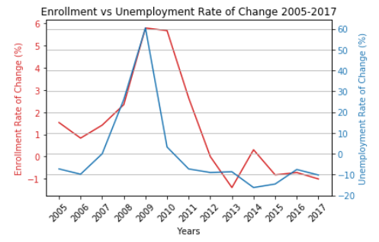

**Figure 2: Annual Completion rate of change**

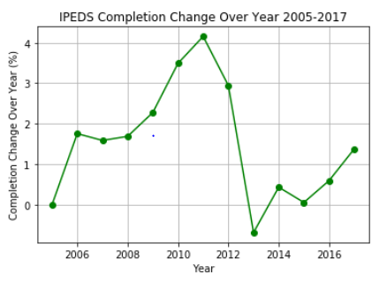

## B. As unemployment rates increase, do enrollment rates increase in response?

## 

In addition to analyzing the changes in the rates of these parameters, it is also important to examine the rates themselves. Figure 3 illustrates the average annual unemployment percentages and Figure 4 depicts the enrollment rates through 2000-2018. A direct correlation is observed between unemployment rate and the number of student enrollment. A comparison between the two figures provides the insight that as the unemployment rates increase, so does the enrollment rate. For example, as the unemployment rate peaked in 2010, a peak in enrollment count was similarly observed in the following year, 2011.

**Figure 3: Unemployment Rate (2000-2018)**

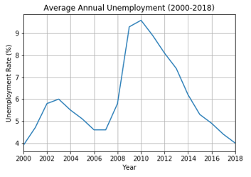

**Figure 4: Enrollment Rate (2000-2018)**

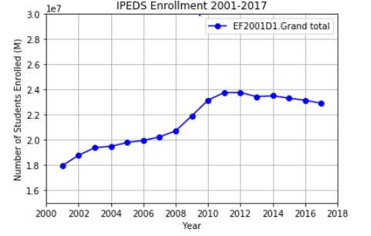

## C. Does a correlation exist between completion rates and employment rates

A final observation is the positive correlation between completion rates and employment rates. Examination of Figure 5 indicates similar trends between average annual unemployment trends with degree completion rates, specifically with 1 to 2-year degree programs. It appears that during the Recession, there shorter programs were higher in demand. However, it is also important to note that during this time period, the majority of the degrees attained were bachelor’s degrees. Figure 6 illustrates the clear preference for attaining a bachelor’s degree (~87%), in comparison to any alternative degree. Comparing this observation with the years of the Recession, it can be noted that the highest annual rate of change in completion was observed in 2011, exactly four years after the start of the 2007 recession (Table 1). As four years is also the duration of attaining a bachelor’s degree, this supports the argument of the correlation between completion rates and unemployment rates.

**Figure 5: Unemployment rate and type of Degree Awarded** 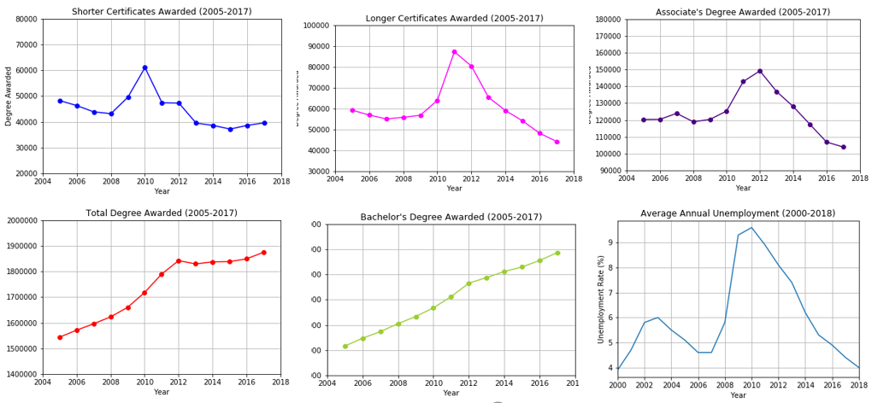

**Figure 6: Percentage of Completion Degree Types (2005-2017)**

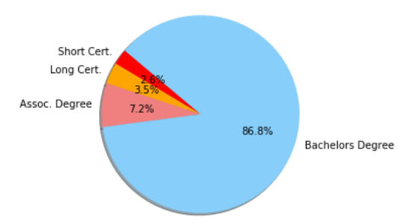

## D. Discussions and Future Questions to Explore

We have successfully established a correlation between unemployment, enrollment and education rates. It would be insightful to explore the following questions: Can we predict the future employment rate based on the current college enrollment and completion rate? Did the economy recover from the Great Recession with the more qualified workforce with higher education? With the increase in graduates, are the jobs being retained locally rather than outsourcing overseas? Or is there more independent entrepreneur to impact the economy? Finally, how the educational institutions are evolving to adapt to the need for the current workforce?